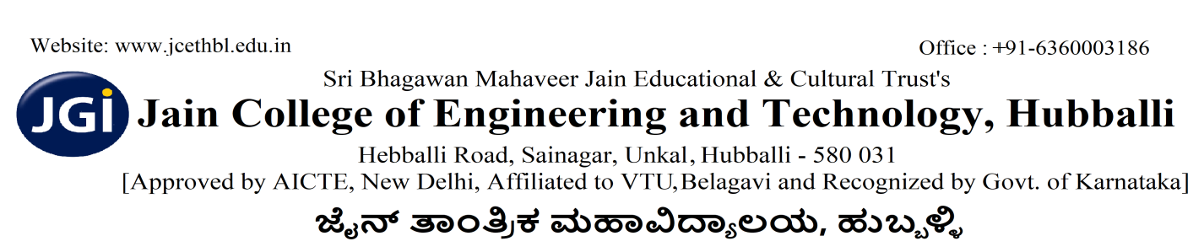
VAIBHAV 2K26
COOKING WITHOUT FIRE

- Maximum two members should be in a team to participate in the event.
- Duration is of one hour
- Participants should not bring any pre-cooked items.
- Pre-registration mandatory
- All the items required for cooking should be brought by the participants themselves.
- Dishes should be purely vegetarian.
- Participants should not bring any cut, chopped or grates raw materials.
- They should process it on the spot within allotted time.
- The evaluation will be based on the taste of the dish, cleanliness and presentation, unique name of the dish.

Faculty Co-ordinator:
Prof. Kaveri Talawar
Prof. Joyce Francis

Student Co-ordinator:
1) Rebecca (III sem ECE)
2) Malvika (III sem ECE)

PRINCIPAL

